WUNSCH & CO CLIENT PORTAL

Procedures for secure transfer of your documents and
electronic signatures

Access to the Client Portal
You will receive an email from us containing instructions and a link to take you to the log on screen to set up an account. Our Wunsch & Co link is:

https://documenthub.handisoft.com.au/ClientPortal/Account/Login/WUNS0001

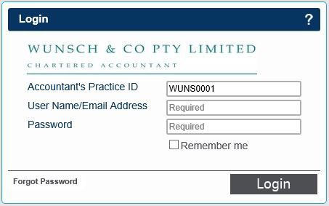
You will then be asked for the following information:
Accountant’s Practice ID – WUNS0001 Username – enter your email address (please override any reference)
Password – enter or create a password during first log in
If you have access to multiple entities, you will then be asked to select the entity you wish to view from the list. (We can always reset your password).

Viewing Documents
All documents uploaded for your review will be listed. The icons on the left-hand side indicate the required actions.
→ ‘Signature Required’ 
This symbol indicates your signature and review of a document has been requested
→ ‘New Document Uploaded’
This icon indicates the documents that have not yet been viewed

Downloading Documents
To download & save/print documents from the Client Portal, click on the  icon that will be located to the left of each document name. You can access these documents at any time via the web address above.

Electronic Signatures
To electronically sign documents on the Client Portal, you must download the document using the instructions above and review it. Once downloaded, you will be able to sign by clicking on the icon also located to the left of the document name.
Electronically signed documents will be identified in the Client Portal by the signed  icon. We will receive a notification and the signed copy of the document will remain accessible on the Client Portal.
This electronic signature is accepted by the Australian Taxation Office and many other statutory and regulatory bodies. Once the document has been ‘signed’, an additional page will be added to the document showing the electronic signature.

